Deerwalk Institute Of Technology
Database Administration

Lab:

Submitted By: Submitted To:
Name: Sagar Giri Narayan Chalise
Roll No. 205

Date:

Create a user first:

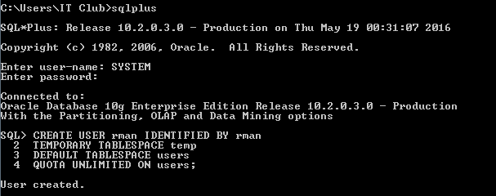

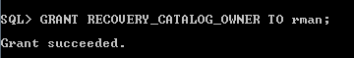
Grant RECOVERY_CATALOG_OWNER to the created user.

Exit SQLPLUS and connect to newly created user using CATALOG parameter

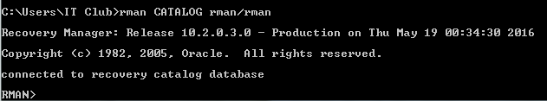

In RMAN console, create a CATALOG


Try registering database using REGISTER DATABASE command:

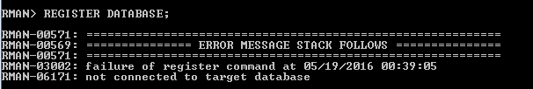
It will generated error because, target backup database is not connected. So, we need to exit SqlPlus and connect to target databse.

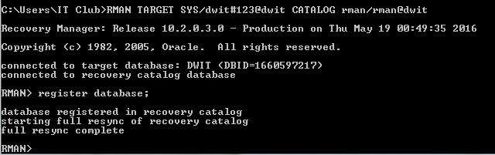
Now, we can register our database for the backup process.

BACKING UP DATABASE

a) Offline Backup
Offline backup is done while database instance is in shutdown state. To shutdown the database, first we need to login in SqlPlus with SYS AS DBA user and initiate SHUTDOWN IMMEDIATE command.

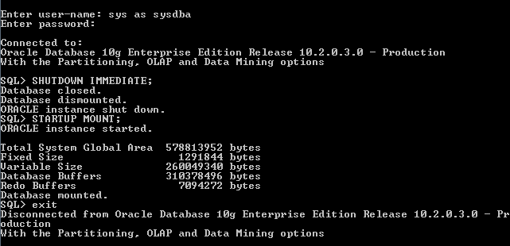
Now in another window, login to RMAN console using
RMAN TARGET SYS/<pass>@<db_instance> command.
After login is successful, BACKUP DATABASE; command will backup the whole database.
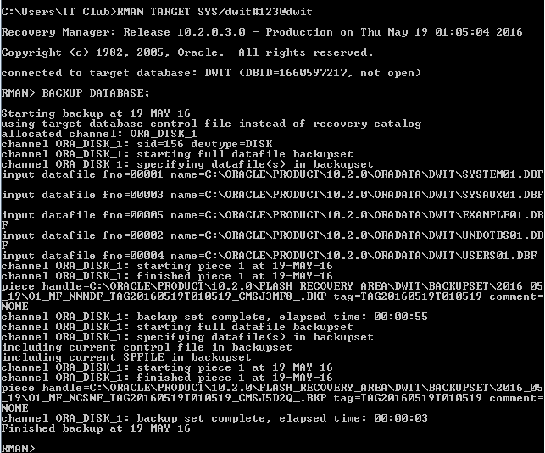

b) Online Backup

For the online backup, database instance should be in the ARCHIVELOG mode. To know the log mode of the database, run SELECT LOG_MODE FROM V$DATABASE command;
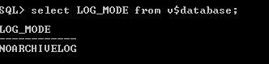

To change the LOG_MODE, fire ALTER DATABASE ARCHIVELOG command.
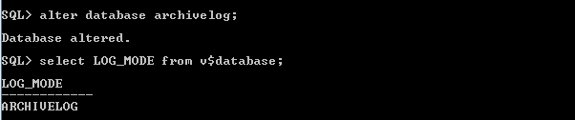

Now, we can do Online Backup. To do so, login to RMAN console, using target database username and password. And fire BACKUP DATABASE command.
